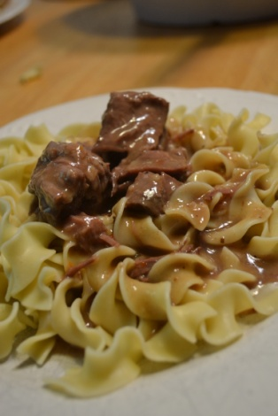Easy Beef and Gravy
(Yes I have a few minutes to make the gravy) this is my family favorite version
- 1 beef roast
- 2 cans of beef broth
- 1 package of Good Season Italian salad dressing (dry kind)
- ¼ cup flour
- salt and pepper meat and Brown meat on stove
- Place in crock pot
- Pour 1 can beef broth in browning pan
- Add slow flour to pan stirring with a fork to not have lumps
- Add 2nd can of broth
- Once gravy thickens pour over meat in crock pot
- Add Good Seasons Italian package (dry)on top of meat
- Cook for 6 hours
Serve with egg noodles From www.superexhausted.com
Easy Beef and Gravy
(This is the no time to make gravy in the morning version)
- 1 beef roast
- 2 cans of beef broth
- 1 package of Good Seasons Italian package (dry)
- ¼ cup flour
- salt and pepper meat and Brown meat on stove
- Place in crock pot
- Pour beef broth over roast
- Add Good Seasons Italian package (dry) on top of meat
- Cook for 6 hours
- Take out meat
- Using a measuring cup take 1 cup of hot liquid add flour to cup mix till well incorporated (this is to avoid lumps)
- Add broth flour mixture to crock pot mix in till flour/broth well incorporated
- Add meat back wait for gravy to thicken
Serve with egg noodles From www.superexhausted.com

