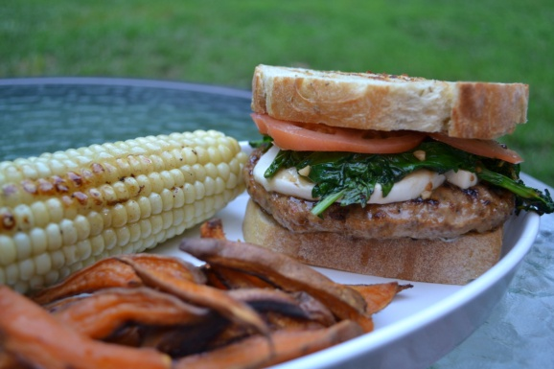

Taste of Italy Burger

- 1 package of Johnsonville Mild Italian Sausage Sandwich Patties (6)
- 1 loaf of crusty bread cut ½ slices (I used a rosemary thyme bread)
- Broccoli Rabe leaves 1 head (reserve heads for side dish)
- 4 tbls of butter
- 1 garlic clove finely chopped
- Fresh Mozzarella
- 1 slicing tomato
- ½ cup of mayo
- ½ TBLS of dried basil or fresh basil 1 TBLS

- Cut bread in ½ slices butter both sides and place on grill till toasted on both sides
- Place Johnsonville Sausage patties on the grill cook as directed on the box
- On side burner sauté broccoli rabe leaves with butter and garlic for a few minutes till wilted
- Cut Fresh Mozzarella into slices ¼” thick- set aside
- Cut Tomato into thin slices-Set aside
- In a separate bowl mix the mayo with the basil
- Assembly : Spread the Mayo/basil on bread, next the Johnsonville Patty , Mozzarella, tomato, Broccoli Rabe, then top with more mayo and remain Toasted Bread top.
I served with baked sweet potatoes fries and grilled corn.
Located at www.superexhaused.com/cooking

