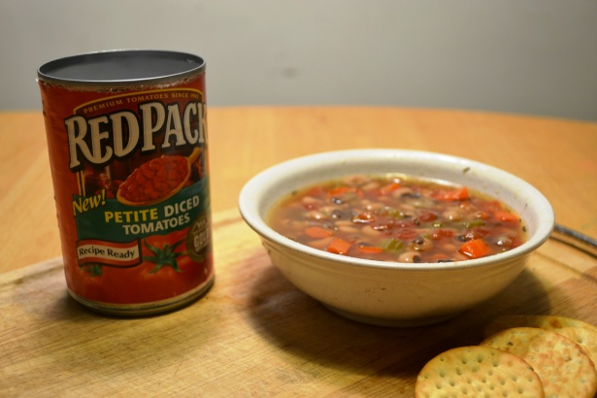
Black Eye Peas Soup Symbolizes Good Luck in the New Year
- 2 cups of dried Black Eyed Peas
- 2 carrots diced
- 2 stalks of celery diced
- 1 onion diced
- 1 tps salt (added as needed)
- 1 tps thyme,
- 2 cloves garlic Minced
- 1 smoked turkey leg
- 8-10 cups of low sodium chicken broth (an additional 4 cups needed if you want to stretch)
- Optional :spicy sausage to add flavor

- Bean cooked on low in slow cooker for 2 hours covered in 4-5 cups of broth
- When black eyed peas are firm /rehydrated but not to cooked add other ingredients
- add smoked turkey leg, spices, carrots, onions, celery, garlic, remaining broth
- Cook for 5 hours (now add sausage)
- Cook for another 4-5 hours. You can eat now but if you make a day ahead add more both 2-4 cups let sit overnight.. this soup gets better the longer it sits.

You can also omit the turkey leg (sausage), add cumin and make a vegetarian version
This recipe is from www.superexhausted.com/cooking/

