Red Pack Christmas Chili 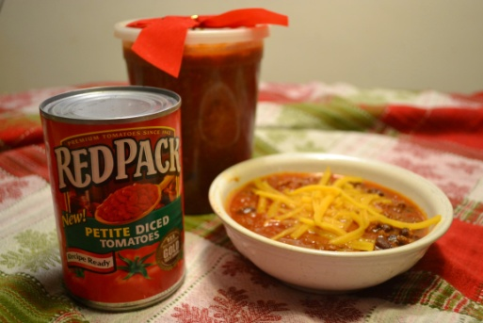
- 3 med onions (Diced)
- 1 garlic clove
- 2 lb of ground beef (or turkey)
- 1/3 of a package of pulled pork seasoning
- 1 tbls cumin
- 1 tbls of chili
- 2 tbls of coco powder
- 1 Jalapeño pepper {deseeded and diced)
- 1 can of kidney beans (drained and rinsed)
- 1 can of white beans (drained and rinsed)
- 1 can of black beans not drained
- 1 can of “Red Pack” Diced tomatoes
- 1 can of “red Pack” Petite Diced tomato
- 1 can of “Red Pack” tomato Paste
- ¾ cup of Brown Sugar
- Optional, 1 tbls of soy sauce, 1 tbls spoon of hot sauce

- Dice onions and garlic place in large pot caramelize onions with butter until golden, translucent and brown- remove from pot.
- Without cleaning pot brown ground meat on onion juices add a generous amount of salt to meat
- Drain grease off of meat , add onions/garlic back to pot
- Continue browning add 1/2 of the Jalapeño pepper (deseeded and diced) brown with meat
- Add the 1/3 of package of Pulled Pork seasoning and Cocoa to meat, stirring
- Add The beans, Red Pack Tomatoes, Red Pack Tomato Paste, and Brown Sugar. All ingredients can go in pot.
- Cover, cook low simmer, stirring occasionally let cook for 3-4 hours
- Jar or put in Plastic containers for giving

