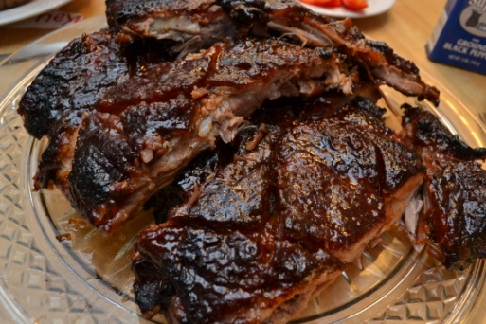
Sweet BBQ Ribs w/Red Pack Tomatoes
- 1 rack of ribs (full rack)
- 2- 2 ½ cups of brown sugar (dark)
- ¼ cup apple cider vinegar
- 1 tbls of molasses (too much leaves a funky taste)
- 4 tbls of honey
- 1 can of “RedPack Tomato” Paste
- 1 tbls spoon of garlic
- 1 tbls spoon of salt
- 2 tbls of hot sauce
- 1-2 tbls of soy sauce (optional)
- Variety of Spices Salt, Pepper, Onion Powder, Chili Powder, Cumin , Powder Ginger
Prep time short.. But overnight- 4-5 hours cooking
- The night before cooking ribs. Season ribs with generous about Salt, Pepper, Chili Powder, Cumin, ginger.. basically use most of the spices in your cabinet. Then wrap in Tin foil and keep in fridge overnight.
- Next Day Preheat oven to 325 degrees,
- Start BBQ Sauce
- In a medium pot, Start with garlic, then add the Red Pack tomato paste, vinegar, salt, molasses , honey and 1 ½ cups brown sugar (reserve rest of Brown sugar for later).
- Bring to bubbling (not a full boil) Watch so it does not burn. Reduce and let simmer on low while prepping ribs.
- Put ribs on a tray with a grate (I suggest tin foil tends to get sticky)
- Brush ribs with BBQ sauce and start cooking on oven (low and slow)
- Every so often cover ribs with BBQ sauce. Flipping ribs every 45 min-1 hour baste w. bbq as you flip. Last hour meat side up
- The Last hour coat ribs in Sauce and top with a sprinkle of brown sugar.
- Last ½ hour coat again with BBQ sauce and brown sugar again.
- Ribs should be pulling away from the bones on the ends that how you know they are almost done. It takes about 4-5 hours
- Last 5 min turn on broiler watching so not as to burn, let the sugar get dark and yummy.
Serve with sweet potatoes fries or a great back potato. Steam Broccoli is a great veggie with ribs.

Can be found at & Recipe written by http://superexhausted.com

