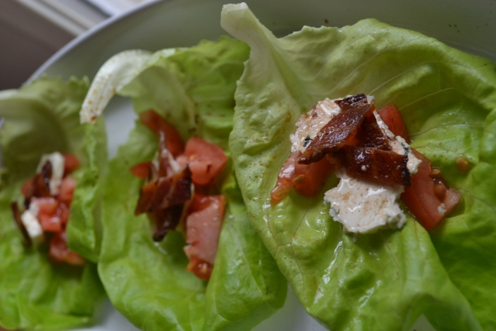
Blue Cheese Wedge Lettuce wraps
- 1 head of Boston Bib lettuce
- Solid blue cheese ¼ lb
- Thick cut bacon
- Plum Tomatoes diced
- Olive Oil
- Balsamic Vinegar

- Clean and wash lettuce keeping leaves in tack (bib lettuce is great for wraps because the are flexible)
- Cook the bacon draining fat
- Assemble
- Lettuce, tomato, blue cheese ,bacon, Drizzle with oil and vinegar- Wrap and eat
I like the balsamic in a spray container so it is evenly distributed I found mine at Trader Joes
- Variations- add sour cream or an hard boiled egg

This original recipe and more can be found at www.superexhausted.com

