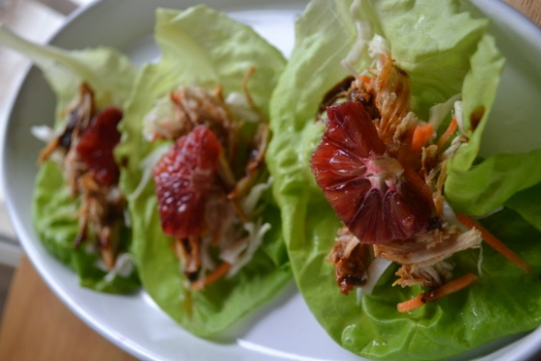
Fire Cracker Chicken Wraps
- 1 or2 Chicken breasts
- 1 head of Boston Bib lettuce
- 2 cups Orange Juice
- 1 tbls Honey
- 1 lime
- 1 blood orange
- 4 tbls Soy sauce
- ¼ rice vinegar
- Lime
- Sugar
- Cayenne pepper
- 1 package of shredded coleslaw
- Salt pepper
Prep:
- In a plastic bag, 1 cup of OJ, 2 tbls of Soy, 1-tbls spoon of honey, 1tbls of Cayenne pepper salt pepper, Place thawed chicken in Marinade for 2-3 hours or overnight.
- Separate bowl place ½ a bag of coleslaw, 2 tbls of sugar, ¼cup rice vinegar , juice of a lime, pinch of salt mix sit for 2-3 hours over night.
Cook:
- Fry or grill chicken till cooked, add marinade in pan while cooking to keep moist. Remove chicken to a separate plate allow to cool so you can shred with a fork.
- Deglaze the chicken pan with 1 cup orange juice and 2 tbls soy sauce to make a reduction
- Clean and wash lettuce keeping leaves in tack (bib lettuce is great for wraps because the are flexible
Assemble: Lettuce, coleslaw, shredded chicken , drizzled with oj/soy reduction, top with blood orange
This original recipe and more can be found at www.superexhausted.com

