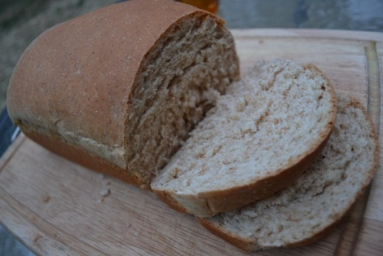
Bread in a Bag

2 cups all purpose flour 1 cup hot water
1 package yeast (125-130 degrees)
3 tablespoons sugar 3 tablespoons vegetable oil
3 tablespoons nonfat 1 cup whole wheat flour
dry milk 1 1 gallon freezer bag with a
1 teaspoon salt zipper lock

- Combine 1 cup all purpose flour, undissolved yeast, sugar, dry milk, and salt in a freezer bag. Squeeze air out of bag.
- Shake and work bag with fingers to blend ingredients.
- Add hot water and oil to dry ingredients. Reseal bag, and work again with fingers.
- Add whole wheat flour. Reseal bag and mix thoroughly.
- Gradually add enough remaining all purpose flour to make a stiff dough that pulls away from the bag.
- On a floured surface, knead dough 2-4 minutes until smooth and elastic.
- Cover dough, let rest 10 minutes. Roll dough to 12x7" rectangle.
- Roll up from narrow end.
- Pinch ends and edges to seal.
- Place in greased loaf pan, cover.
- Place shallow pan on counter filled with boiling water.
- Place a baking sheet on top, place covered loaf pan on top of baking sheet.
- Let rise 20 minutes or until double in size.
- Bake at 375 for 25 minutes or until done.

Recipe found at www.superexhausted.com/bread-in-a-bag

