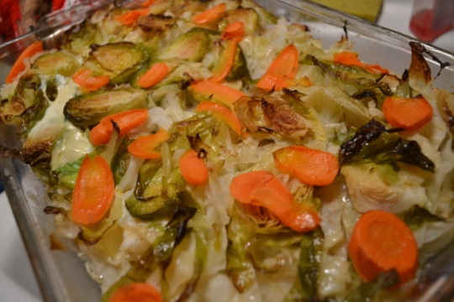
Cabbage Casserole
- 4 potatoes peeled sliced thin 1/8”
- 1 head of cabbage remove outer layer slice thin
- 3 carrots sliced thin 1/8”
- 7-9 Brussels sprouts sliced
- 1/2 can of chicken stock (healthy) or ½ stick of butter
- Cumin (sprinkle)
- Salt
- Pepper

- Preheat oven 350 degrees
- Slice potatoes place on bottom of dish
- Layer cabbage then carrots,
- adding salt pepper , cumin to taste each layer
- Layer potatoes, cabbage, carrots finish with Brussels sprouts.
- Pour butter or chicken broth over top
- Place in oven and cook for 30min or till fork tender
Located at www.superexhuasted.com

