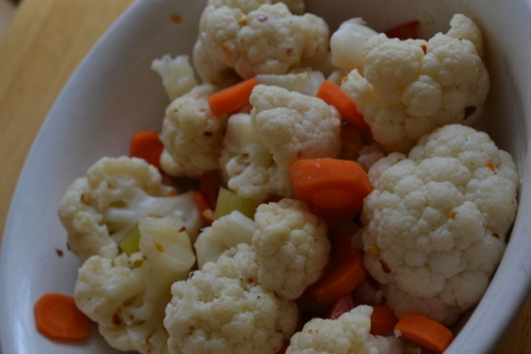
Spicy Cauliflower Salad
- 2 cups vinegar
- 2 cups of water
- 2 tbl of vinegar
- 1bulb of garlic (5- 6 cloves)
- 2 bay leafs
- 1 tbls red hot pepper flakes
- 2 tbls of salt
- 1 head of Cauliflower
- 2 celery stalk
- 2 carrots
- 1 bell pepper (any color , green, red, or yellow)

- Put all the wet ingredients, ½ the red pepper flakes, Bay leaves, and garlic
- Bring to a boil
- Add the Cauliflower, celery, and carrots, 1 pepper
- Bring to a boil reduce heat and cook for 6 min (till cauliflower is tender)
- Remove from heat and allow to cool 5 minutes
- Drain liquid reserve the liquid.
- Put the salad in a bowl sprinkle with remain hot red pepper flakes and sprinkle with salt and add ½ cup of liquid .
Tip; Use remaining liquid add 1 cup of water 1 could of garlic and add green beans bring to boil and store green beans in the liquid for a spicy green been treat.

Then recipe is from www.superexhauted.com /Cauliflower -Salad

