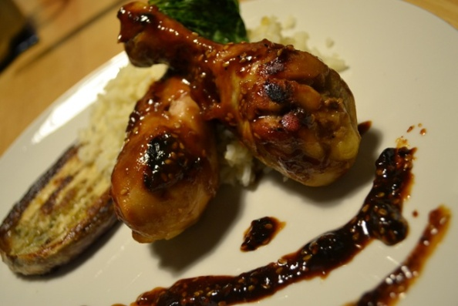
Sesame chicken legs
- 1 package of Gold N Plump chicken legs
- ½ cups of soy
- ¼ of Dijon mustard
- 1 tbls olive oil
- ¾ cup honey
- 2 tlbs of spoon of toasted sesame
- Clove of garlic
- 1 tsp of ginger

- Parboil your chicken leg in water for 15 minutes till cooked thoroughly.
- Mix remain ingredients in a zip lock bag to make the marinade
- Then place cooked chicken legs in the marinade
- Let legs marinate for 30 minutes
- Heat a sauté pain us a little oil or butter in pan to avoid sticking brown the chicken legs slightly.
- Then pour marinate in pan and allow the chicken to finish cooking allowing the marinate to reduce and thicken.
- Remove and serve with favorite side.
This recipe is from www.superexhausted.com/Sesame-chicken-legs/

