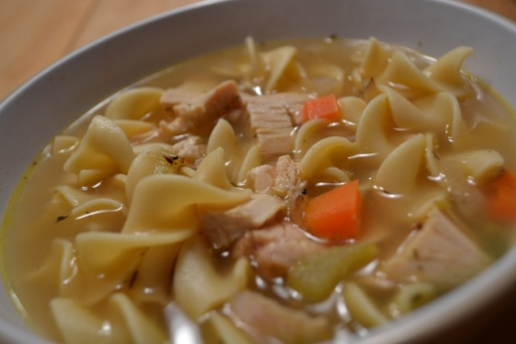

Lemon Chicken Noodle Soup
- 3 celery stalks diced
- 3 -4 carrots diced
- 2 onions diced
- 5 cloves garlic chopped
- 1 bag of extra wide egg noodles
- 2 quarts of chicken broth
- 2 lemons (juiced)
- 1/4 of thyme
- 1 chicken cooked picked off the bone and diced (rotisserie kid you get precooked at grocery store) or chicken parts cut up to bite size pieces
- salt
- pepper to taste
- condensed chicken stock (optional)
- In a large pot add onions, celery , and carrots cook till translucent, salt and pepper to taste
- add chicken broth, bring to boil
- add lemon juice and thyme, extra chicken condensed stock
- add chicken to boil water if uncooked allow to cook till chicken is full cooked
- bring to boil
- add egg noodles for desired time required on package
This recipe is from www.superexhuasted.com

