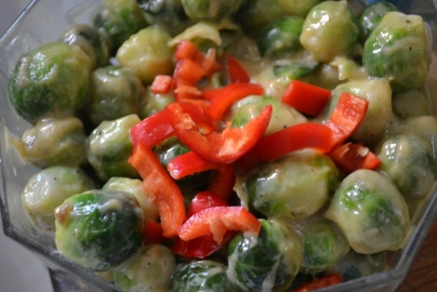
Cold Brussels Sprout Salad
- 1-2 lb of Brussels sprouts
- 4 bulbs of roasted garlic
- ¼ cup of olive oil
- Red pepper diced
- Salt/pepper
Ahead of time: How to roast garlic(cut tops off garlic, pour olive oils and sprinkle with salt wrap in tin foil cook for 1 hour) till caramelized .
- Steam Brussels sprouts till fork tender
- In mini food processor put all garlic removed from skins
- Add oil till roasted garlic is a smooth paste
- Salt and pepper to taste
- Mix in with Brussels spouts and garnish with pepper
- Chill and serve

Recipe found at
http://www.superexhausted.com/2012/07/brussel-sprouts-salad/

