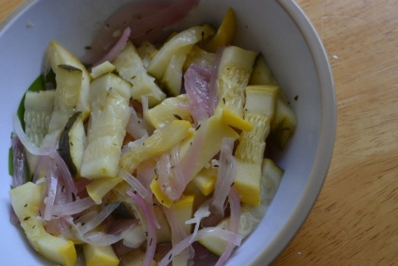
Pickled Squash
- 3 squash (zucchini and yellow squash)
- 1 shallot thin sliced
- ½ cup white vinegar
- ¾ cup apple cider vinegar
- 1 cup of water
- 2 tablespoon of salt
- 2 tablespoon of honey
- ¼ teaspoon of thyme
- 1 bay leaf
- 2 tablespoon of garlic
- Slice the zucchini / squash one of 2 ways strips thing Juliane or slices –set to the side
- In a pot bring the garlic vinegars, water, salt, honey,
- Add onions after boil cook for 3 minutes
- Add squash (cook 2 minutes for squash strips, or 5 minutes for sliced squash)
- Spoon out into a dish with slotted spoon and refrigerate for 1-2 hours (Reserve liquid for other picking ) see below
- Sever as a side
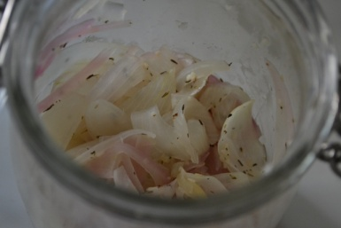
Pickle Onions
- Used reserved pickled broth
- cut up 2-3 onions
- cook onions for 4 minutes
- Spoon out onions to stop cooking process Refrigerator
- Allow liquid to cool then add to chilled onions
This recipe is from www.Superexhausted.com/Pickled_squash/

