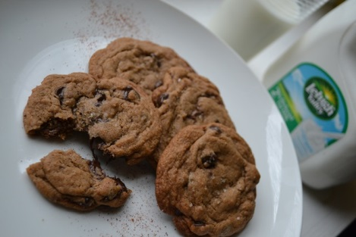
Sinners Chipotle Chocolate Chips Cookie
- 1 stick of unsalted butter
- 8 tablespoons of refined coconut oil (you can always use one stick of butter)
- ¾ white sugar
- ¾ brown sugar
- 2 large eggs
- 2 tablespoon of corn syrup
- 2 teaspoons Mexican vanilla extract
- 2 ¾ cup flour
- 2 teaspoons cream of tartar
- 1 teaspoon of baking soda
- ¼ teaspoon salt
- 3 table spoon of powered baking chocolate
- 3-4 teaspoons of chipotle (dried) I used 4
- 1 16 oz package of semisweet chips
- 8 oz milk chocolate bar chopped up
- Smoked bourbon sea salt

- Preheat oven to 350
- Beat butter, coconut oil, and sugars until well blended and smooth
- Add eggs, corn syrup and vanilla to sugar blend until light and fluffy
- In separate bowl mix all dry ingredients flour, baking soda, cream of tartar, salt, powder chocolate, chipotle an blend well with a fork.
- Slow add the dry ingredients in to the wet a little bit at a time till all ingredients are well blended
- Then add the chocolate chunks and chips in the dough
- Scoop out using cookie scoop place 2” apart on a parchment lined cookie sheet and sprinkle each cookie with sea salt
- Bake for 9 minutes
- Allow to cool and enjoy with milk
Yields 36 cookies

http://www.superexhausted.com/2012/12/chipotle-chocolate-chips-cookie/

