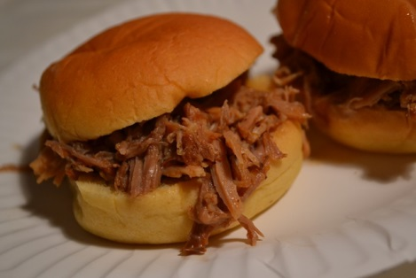
Pulled pork
- 4-6 lb pork roast or pork shoulder
- ½ cup Apricot jam
- ¼ cup soy sauce
- 1 Onion med
- 14 oz can Pork or Chicken broth
- ¼ cup brown sugar

- Caramelize onions in ninja with pat of butter till golden brown
- Brown pork on all sides
- Pour broth in pot, cover with jam, soy, brown sugar and remain ingredients on pot
- Cook for 5 hours on low till fork tender
- Remove bone, fat if any and shred with 2 forks pulling the meat apart
- Enjoy on a roll (you can add barbeque on side)

http://superexhausted.com/pulled-pork/

