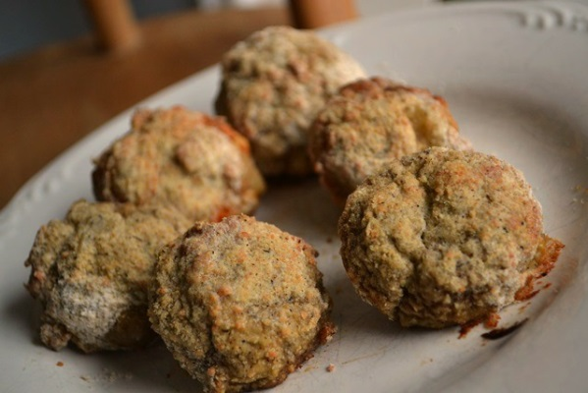
Skinny Fake Fried Mushrooms
- 1 pound of White Button Mushrooms
- 1 egg
- ½ cup all purpose flour
- 2 tablespoons of pepper (you can use less, but yummy)
- 4 tablespoons of grated Parmesan
- 1 tea spoon garlic salt
- 1 teaspoon of onion powder
- 1/8 cup Hot sauce

- Preheat oven to 425
- Mix flour will all dry ingredients
- Crack and beat raw egg
- Clean mushroom with paper towel (don’t wash with water), trim bottom of stems leaving attached
- Dip mushroom in egg wash (if you want hot sauce – dip in hot sauce then egg)
- Dredge in flour mixture
- Place on baking tray
- Cook for 15-20 minutes
- Check increasing heat to 450 watch careful to make golden brown
- Remove and eat ( you can dip ranch or blue cheese)
http://www.superexhausted.com/2013/02/skinny-fried-mushrooms/ ‎

