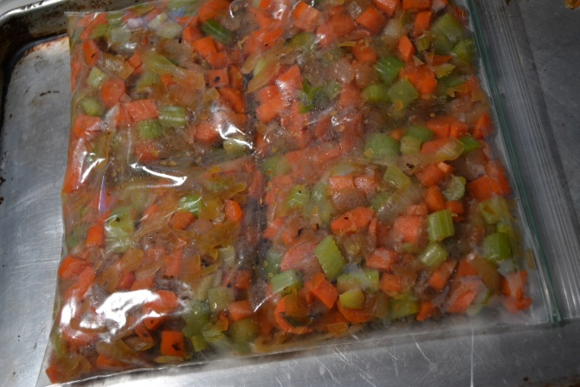
Ready to use frozen Mirepoix.
- 6 onions
- 2 lb of carrots
- 1 head of celery
- salt
- 2 tbls oil or butter

- Dice Onions and start saute in large pot with oil/salt on low
- while onions are cooking peel carrots and dice ( I prefer a whole carrot to mini ready to eat carrots) add to onions
- Then clean celery dice and add to carrot onion mixture. salt
- Cook stiring till carrot are tender (not mushy)
- Remove from pot in large pot to large bowl allow to cool.
- Place cooled Mirepoix 7-8 cups in a gallon freezer zip lock (you can use quart size bags -2 cups per Bag)(I was out of quart and prefer to use less plastic,
- Place on a large cookie sheet, laying bag flat, Using back of knife press into bags to create separate sections
- 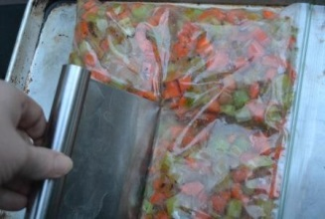
- Freeze.. checking to make sure sections stay separated during freezing process.
- Now ready to use simple break off a sections and place in pan for cooking. should speed up your cooking time.

What to use MirePoix for: stews, soups, casserole, any thing where you want a great flavor base with out the time.

From http://www.superexhausted.com/?p=3933

