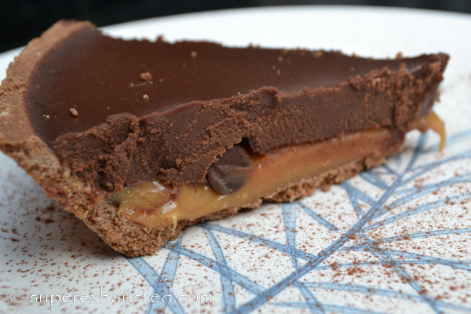

Brenda’s Chocolate Caramel Pie
Ingredients:
- 28 caramels (un wrapped)
- 1 stick of butter
- 6 oz semi sweet chocolate chips
- 1 cup of heavy cream
- Gram cracker Pie crust
- Sea salt (optional topping)
- Nuts (Optional topping)

- Melt caramels, 2 tablespoons of butter and ¼ cup of the heavy cream in pan
- Pour caramel into pie crust, sprinkle a few of the chocolate chips on caramel
- Melt chocolate, 6 tablespoons of butter, ¾ of heavy cream in pan, on low heat stiring slowly, do not boil, the chocolate and cream will separate.. slow and stir the entire time
- Pour chocolate on caramel
- Refrigerate for several hours
- Top with toasted nuts, or sprinkle some sea salt.. or just eat

Recipe from : http://www.superexhausted.com/2013/03/easy-chocolate-pie/ ‎

