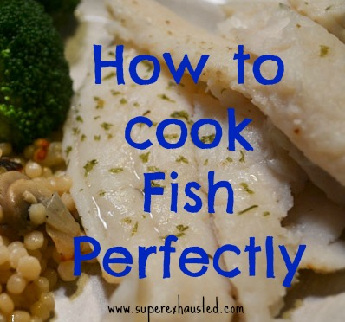
Easy Recipe for Perfect Fish
- 1 1/2 lb of white fish
- 1 teaspoon of butter or oil
- 1 teaspoon of garlic
- 10 mushrooms sliced
- 1 small onion diced
- Israel Pearl style couscous (I found mine at Target in the ethnic food isle
- 1 can 14oz of chicken broth
- 1 bunch of broccoli or asparagus
- salt & pepper for fish uncooked fish

- Tools a Ninja cooking system or a pot with steamer basket (I prefer my ninja for simple clean up and cooking method) It is a layered method.
- Sauté with butter, onions, garlic, and mushrooms in bottom till onions are translucent
- Add couscous with 1 can of broth couscous
- then layer the vegetable (broccoli or asparagus)
- season fish and place in mesh steamer basket and place on top of veg/couscous fish layered over the couscous
- Cover and cook for 15-20 mins once fish is done
http://www.superexhausted.com/2013/03/easy-fish-recipe/

