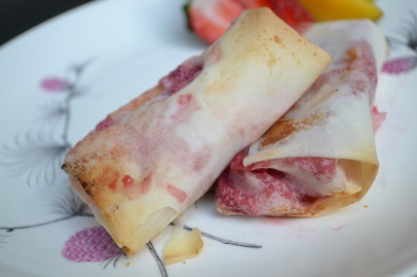
Mango Berry Spring rolls
Great Low calorie dessert great for diabetic and reduced calorie.
Makes 6-8
Prep 10min
Cook 8min
Calories under 150
- 1 mango- cut into small chunks
- 1 pint of strawberries cut in to small bites
- 1 Prickly Pear aka Cactus Fruit cut to small bites
- Sprinkle flour (for thickening)
- Sprinkle of brown sugar or sugar alternative stevia
- Sprinkle of salt to bring out flavors
- 1 Tbs spoon of honey (or agave liquid for diabetic)
- 1 package of spring roll wrappers Thawed
- Optional Whip cream on side (your choice)

- Mix cut fruit, with sugar, honey, sprinkle flour and sprinkle of salt to bring out flavors
- Lay out spring roll on baking sheet, add fruit on one end, fold sides in then roll.
- You can use honey to seal ends
- Bake for 6-8 minutes watch till looking lightly crispy

http://www.superexhausted.com/2013/04/mango-berry-spring-rolls/ ‎

