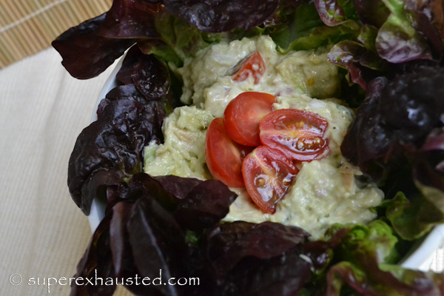
Tuna Avocado and Tomato salad
- 1 can of tuna
- 1 avocado peeled cut in chunks
- 1 small shallot
- Cherry Tomatoes Hand full Sliced in to smaller pieces
- ¼ mayo optional
- ½ lemon squeezed or lime
- Fresh cilantro leaves chopped
- Salt
- Pepper

- Mash the Avocado
- mix all ingredients together
- serve with or on lettuce leaves

This recipe is from http://www.superexhausted.com/2013/05/avacado-tomato-tuna-salad/

