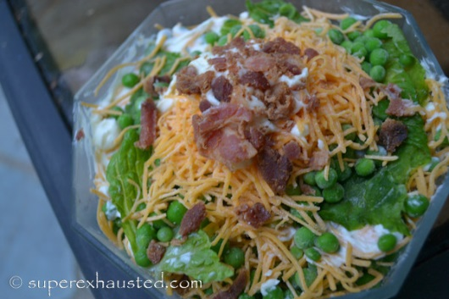

Hendrickson Pea Salad
- 1 package of frozen sweet peas
- 2 cup package of shredded cheddar cheese
- 1 Bottle or package of “Real Bacon” (bits) do not use imitation
- 1 few leaves of romaine lettuce
- 1 cup of mayo

- Put the peas in a colander and rinse with cold water to take the chill of them and so they don’t stick together
- This is a layer dish
- Start with romaine lettuce tear into squares , and lay on bottom of bowl 2-3 quart
- Next the peas a layer of them
- Coat with a layer of the mayo
- Sprinkle some cheese
- Then sprinkle bacon
- Repeat again starting with the lettuce, peas, mayo, cheese, bacon (repeat once more)
- Finsh with garnish of cheese and bacon
- Let sit over night or a good couple of hours to chill up again.
- Mix an hour before serving ( I actually prefer it made ahead and it is better the second day- Left overs)

http://www.superexhausted.com/2013/06/pea-salad/

