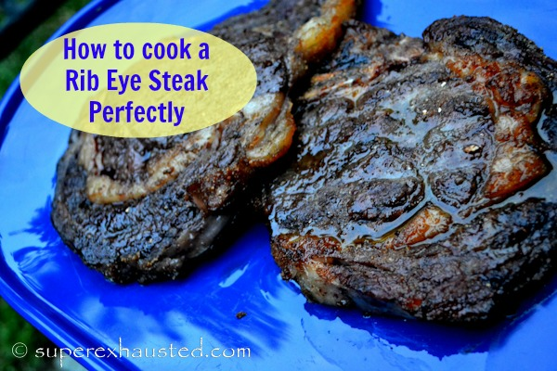
Mushroom Rubbed Steak
- 3- 1 1/2- 2 pound thick steaks (I like the bone in)
- 1/4 of red cooking wine (splash)
RUB:
- 1/3 cup brown sugar
- 1/2 cup dried ground Shiitake mushrooms..(dried 7 mushrooms)
- 1 teaspoon cumin
How to cook a Rib Eye Steak
- The night before generously salt the steaks leave uncovered in the refrigerator
- Steak with dry rub
- 1/2 hour before cooking remove from the cold plate and put rub on steak both sides and push it in
- Allow the steaks to come to room temp w/ rub before placing on grill
- Turn on Grill on high
- Before placing steaks on the grill splash on Red wine vinegar on up side
- Place on grill
- 3 min high - 4 min med each side (Thick steaks close the grill.)
- Allow the steaks to rest 15 min before eating
From blog post : http://www.superexhausted.com/2013/08/how-to-cook-steak/ ‎

