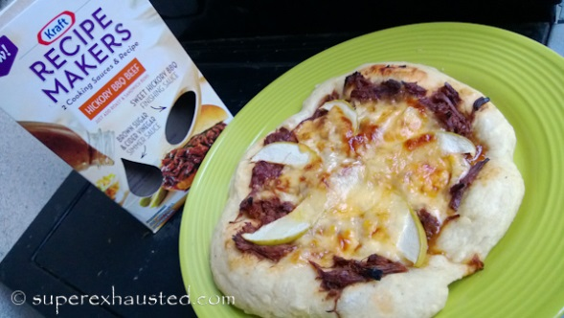

BBQ Pizza with Gouda and Green Apples

Ingredients:
- Kraft Recipe maker BBQ Hickory Beef
- 2-2.5 of beef or pork
- 1 pound of smoked Gouda (non smoked works as well also)
- 1-2 green apples sliced thin
- Pizza Dough (premade or make your own recipe for dough)
- flour for working with the dough

- Cook the beef per the instruction on the Kraft recipe makers
- Place beef in cooker , over with Krafts Brown Sugar and vinegar sauce
- Cook for 6-8 hours in slow cooker or 26 min in pressure cooker
- Allow the beef to cool slight so as not to burn hands, remove from cooker
- Pour or Ladle juices the meat cooked in to separate container- you can use later if need to add more moisture to the meat
- and shred with a fork, by pulling fork through meat. I suggest shredding it finely since you don't want big chunks on Pizza
- Pour over the Kraft Recipe Makers BBQ sauce and mix - set aside
- Next on a baking sheet lined with parchment paper shape pizza crust
- Place the BBQ meat on 1st, then thin apples, then cheese
- Repeat for other pizza
- Place in oven for 25 minutes
- Remove cool slightly and enjoy

http://www.superexhausted.com/2013/09/bbq-pizza/

