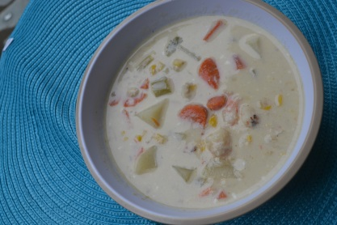
Easy Seafood Chowder:
Makes 8-10 cups Cooks in 30-40 minutes stove top or 2-3 hours crock
- Cook time 30-40 minutes stove top or 2-3 hours crock pot
- 1 onion diced
- 3-4 carrots diced
- 2 stalks of celery
- 1 brick of cream cheese softened
- 6 cups of milk (more or less depending on soup thickness preferred)
- 3 potatoes peeled and diced
- 1 can of corn w/ juice 15.25 oz
- 1 can Cream of Mushroom Soup, 10.75 oz
- 1 can of can crab 6.5 oz(you can buy the expensive lumped meat or the simple can on the shelf= your choice)
- 1 can of clams 4.5 oz(chopped or whole - then chop the whole again size depends on amount of clams- 10-13 oz can)
- 1 bag of frozen shrimp uncooked 12oz or 16 oz (tails on or off - remove tails prior to cooking- size your choice based on expense you might want to cut if large)
- 1 bag of scallops optional
- 1/4 teaspoon of cayenne pepper
- Salt and pepper to taste
- Hot sauce to taste
- Optional Garnish Bacon or green onions

How to make Seafood Chowder:
- In a large pan sauté, onions, carrots and celery making a Mirepoix (time saving tip use frozen mirepoix )
- Transfer your Mirepoix to a crock pot or large soup pot
- Add brick of cream cheese allow to melt (or melt in microwave for 30-1 minute till smooth) dont burn
- Then dump mushroom soup, corn w/ juice, potatoes, milk in pot
- Add salt, cayenne pepper, pepper and hot sauce
- Cook till potatoes are soft (20 minutes on stove) (crock pot 2-3 hours)
- Then add sea food clams, crap, shrimp (tails removed and cut to bite size)
- Allow seafood to warm and serve. Try it with a crusty bread
- Quick Crock pot you can do everything on stove and keep warm in a crock pot for a party.

http://www.superexhausted.com/2013/11/easy-seafood-chowder/

