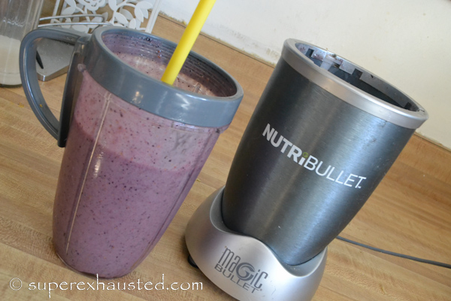
Nutribullet Smoothie Recipe: Ginger Fig

- 1 banana
- 1/4 frozen blueberries
- 1/2 frozen pineapples chunks
- 1 dried fig
- 1 table spoon of grated ginger
- 1 table spoon of honey
- 8-12 oz of almond milk or skim milk

Combined all and Blend in Nutribullet.

Full post can be found here ;
http://www.superexhausted.com/2014/03/nutribullet-smoothie-recipe/

