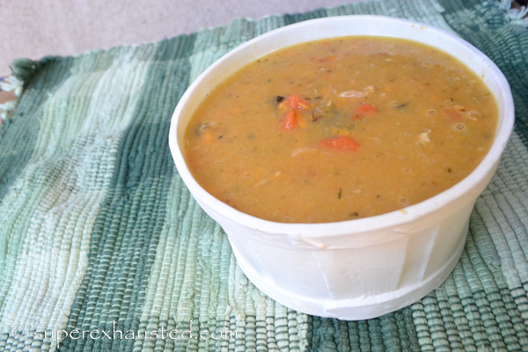
Sweet Potato Chicken Soup

- chicken chopped 3 cups ( or 1 rotisserie chicken Picked)
- 3-4 sweet potatoes pealed and diced
- 1 onion diced
- 4 carrots pealed and chopped
- 1 bay leaf
- 10 mushrooms cleaned and chopped
- 3 cups of water or chicken broth
- 2 table spoon of oil

- In a 6-8 quart pot add oil add onions cook fir 5 minutes
- Add carrots and mushrooms, cook until carrots tender (salt to taste)
- Add 3 cups of water or broth
- Add bay leaf
- Add sweet potatoes cook for 20 minutes med low
- Stir often
- Add chicken cook for another 20 minutes
- Potatoes will break down and thicken up soup add more broth if needed

http://www.superexhausted.com/2014/03/sweet-potato-chicken-soup/

