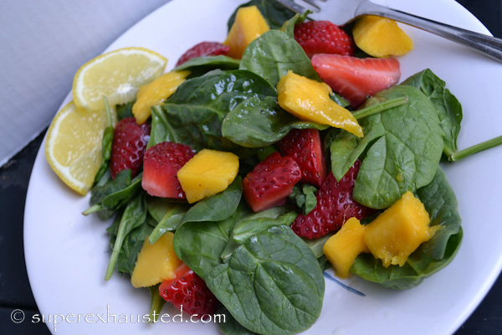
Strawberry Mango Spinach Salad

- Spinach 4 cups
- 1 pint of strawberry clean and sliced
- 1 mango
- Lemon Mustard dressing

Lemon Mustard Seed Dressing:

- 1 juice of Lemon
- 1/4 cup of apple vinegar
- 1/2 cup of vegetable oil
- 1/8 water
- 1 tablespoon of Dijon mustard
- 1 tablespoon of honey
- 1/8 teaspoon salt
- 1/8 teaspoon pepper

- Mix all the dressing the ingredients together
- Mix the salad ingredients and toss with dressing reserve some for later use

http://www.superexhausted.com/2014/04/strawberry-spinach-salad/

