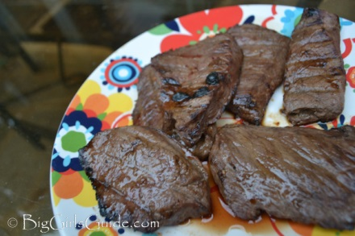
The best venison marinade:

- 2 lb of Venison steaks
- 1 cup of Orange Juice
- 1/4 cup Soy Sauce
- 1 tablespoon of minced garlic

- Put ingredients in a gallon zip lock bag.
- Marinade for 24 hours - or overnight
- Gook on grill or frying pan , med rare
- Let steaks rest 5-10 min prior to eating

http://www.superexhausted.com/2014/06/venison-marinade/ ‎

