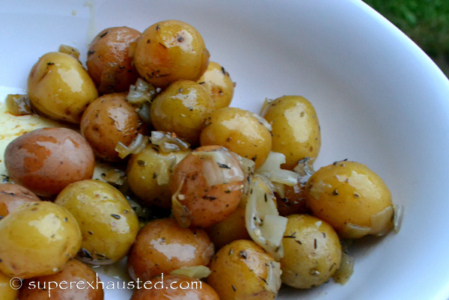
Roasted Baby Potatoes

- 2 lb of baby potatoes
- 1/4 olive oil
- 2 shallots or a small onion
- 1 teaspoon of dried thyme
- salt and pepper

- Wash potatoes
- Minced onions, in a large bowl mix ingredients potatoes
- Create a foil packed for the mixture (do 2 smaller packets so easier to mange) potatoes
- Place on grill for 20-30 minutes till potatoes are fork tender

http://www.superexhausted.com/2014/07/roasted-baby-potatoes/

