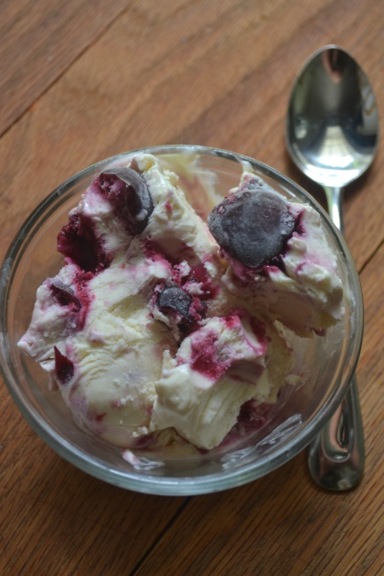
Easy Cherry Cheesecake Ice Cream
- 2cups of cherries pitted, halved and de-stemmed
- 1/8 teaspoon of salt
- 1 tablespoon of lemon juice
- 2 cups of heavy whipping cream (16oz)
- 14 oz of sweetened Condensed Milk
- 8 oz of cream cheese
- 2 tablespoons of sugar
- 1 teaspoon of vanilla

- Cook cherries with lemon and salt over a low/med heat
- Watch till bubbling, juice is released, and starts to thicken and remove and alow to cool for an hour
- In a mixer or large bowl beat cream cheese till smooth
- Then add the condensed milk and vanilla- beat till smooth
- Adding the Heavy cream and beat till soft peaks are formed (will take a while but do not over beat)
- Place 1/2 in a loaf pan and gently fold some of the cherries in the cream mixture. Then add the remaining cream folding the cherries.
- Drag a knife to make a swirl effect.
- Cover and let chill overnight

http://www.superexhausted.com/2014/09/cherry-cheesecake-ice-cream/

