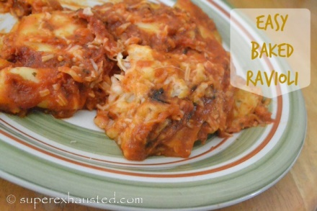
Easy Baked Ravioli

- 1-2 bags of frozen raviolis (I use 2-4lb bags at Walmart)
- 1-2 jars of tomato sauce
- 4 cups of mozzarella cheese (extra needed if making large potions)
- cooking spray

- spray a 9 x12" glass pan or disposable dish with non stick spray
- place a layer of frozen ravioli on the bottom
- Spoon a layer of tomato sauce over ravioli
- Sprinkle a layer of cheese over sauce
- repeat layer, ravioli, sauce, cheese
- Bake 30-40 minutes till bubbling

http://www.superexhausted.com/2014/10/baked-ravioli/

