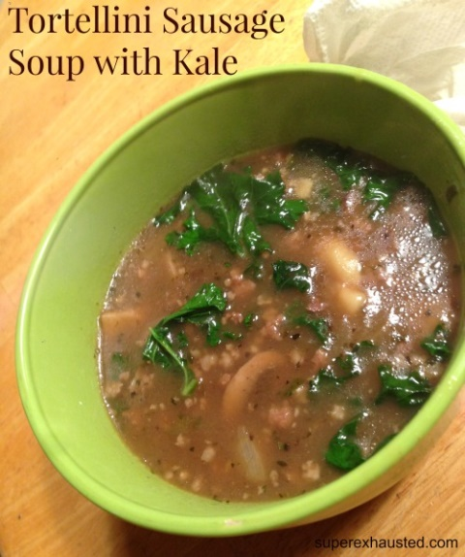
Tortellini Sausage soup with Kale
- 1 lb of of ground sausage
- 1 page of frozen tortellini
- 4 cans of beef broth
- 5 cups of mushroom sliced
- Kale clean and torn
- 1 onion diced
- Salt and pepper
- 3 tbl spoons of corn starch or flour doe thicken
- ¼ tsp oregano
- ¼ tsp basil

- On a large pot Sauté onion and mushroom, season as taste
- Remove onion /mushroom from pot
- In same pot brown the sausage, season meat with salt and pepper drain grease
- Add broth, spices, onion/mushroom
- Bring to a boil, add tortellini
- Reduce to a simmer for 15 minutes
- Add torn Kale before serving

http://www.superexhausted.com/2014/11/tortellini-sausage-soup-kale/

