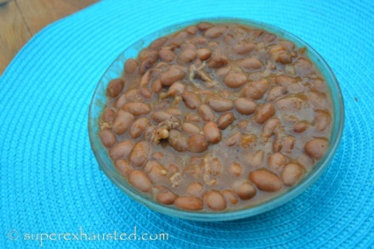
Easy Slow Cooker Beans

- 1 chopped onion 1 bay leaf
- 1 lb of dried beans
- 1 tbls of oil
- 1/4 teaspoon of cumin
- 1 tbls of salt, 1/4 of pepper
- 1 tbls of hot sauce
- 2 garlic cloves smashed
- 1 1/2 cups of vegetable stock,
- optional 3-4 slices of bacon chopped

- The night before place beans in a large bowl pick out any bad beans , cover with water an allow to sit over night
- In the morning rinse beans with water and place in a cover pot on the stove, cover with clean water- bring to a boil and cook for 15 minutes. drain and rinse with cool water. This cooks off any bacteria or toxins
- in a slow cooker place 1 chopped onion 1 bay leaf, beans, 1 tbls of oil, 1/4 teaspoon of cumin, 1 tbls of salt, 1/4 of pepper, 1 tbls of hot sauce, 2 garlic cloves smashed, beans, 1 1/2 cups of vegetable stock, (optional 3-4 slices of bacon chopped)
- Cooks for 8 hours on low

http://www.superexhausted.com/2015/02/easy-slow-cooker-beans/

