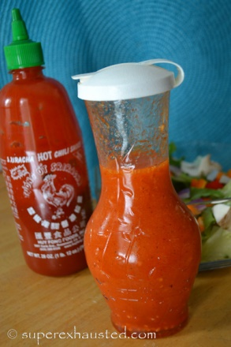
Sriracha Dressing
- 1/4 cup apple cider vinegar
- 1/8 cup or white wine or cooking white wine
- ¾ cup of vegetable or olive oil
- 3 tablespoons of Sriracha
- 1 tablespoon of sugar
- 2 tablespoons of lemon juice
- 1/2 teaspoon of salt
- 1 tablespoon of minced garlic
- 1/8 teaspoon of pepper
- 1 tablespoons of minced onions

Combined the ingredients in a lid container shake vigorously add more Sriracha

http://www.superexhausted.com/2015/03/sriracha-dressing/

