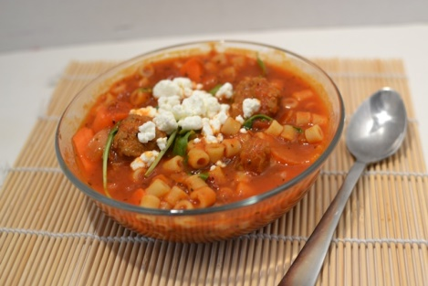
Easy Sausage Pasta Soup
- 24 oz Jar Ragu
- 1.5 pounds of spicy sausage
- 3 medium carrots peeled diced
- 1 medium onion diced
- 2 celery stalks
- 3- 14 oz can chicken broth
- 24 oz of water
- 8 oz dried Ditalini pasta
- teaspoon thyme
- 1/2 teaspoon salt
- teaspoon oregano
- 1/2 teaspoon pepper
- bay leaves
- 1 cup of arugula
- 8oz of goat cheese

- In a large pot brown sausage, removing casing, and drain grease place on paper towel to remove excess grease set off to side
- In same pot add onion carrots and celery brown till carrots are tender
- Add to pot jar of Ragu Sauce, 3 cans chicken broth, 24 oz of water (use the Ragu jar rinse out any left over Ragu)
- Add back into pot drained sausage
- Add Spices (thyme, salt,oregano, pepper, bay leaves) to soup
- Bring to a slow boil
- Add uncooked pasta
- Turn to med heat and cook for 20 minutes
- Before serving Add arugula
- Top servings with Goat Cheese

http://www.superexhausted.com/2015/11/easy-sausage-pasta-soup/

