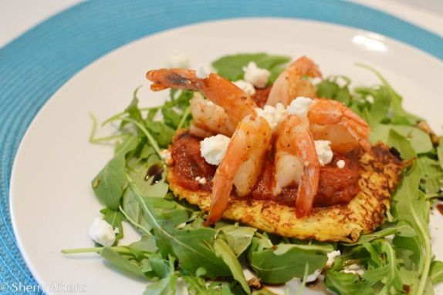
Warm Shrimp Nest Salad
- 1 24oz Jar of Ragu 7 Herb Thick and Chunky
- 1 Spaghetti Squash
- 4 oz Parmareggio Cheese grated
- 2 Eggs
- 8 oz Shrimp - cleaned, deveined, butterfly
- ¼ teaspoon of Minced Garlic
- 4 cups Baby Arugula (2 -4oz packages)
- Balsamic Vinegar
- 8oz Goat Cheese crumbled
- 1 tablespoon Butter
- ¼ teaspoon Salt
- ¼ teaspoon Pepper

- Preheat oven 350 degrees
- Cut spaghetti squash in half lengthwise, place face down in shallow glass pan, with water to cover bottom of pan ,
- Roast Squash in oven 45 min till skin is fork tender. (I recommend roasting night before so has time to cool in refrigerator)
- Scrape out the spaghetti squash into bowl (should be stringing) allow to cool
- Drain any liquid off squash, Add 2 eggs, parmareggio cheese, salt, and pepper mix
- In a preheated frying pan add little butter, Place small amounts of squash mixture flattening in to small (size of your palm) pancakes (too big you won’t flip)
- Fry carefully till both sides are golden brown, remove set on side
- Place Ragu in a pot and bring to temperature
- Take shrimp seasoned with salt and pepper sauté in a pan with garlic till pink and non translucent cooked
- Lay baby arugula on plate, sprinkle with balsamic vinegar
- Stack Spaghetti Squash Pancake, Ragu Sauce, Shrimp, and sprinkle with goat cheese crumbles.

