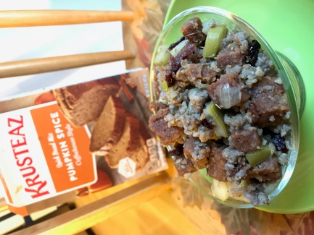
Pumpkin Bread stuffing with Krusteaz Pumpkin Quick Bread mix
Krusteaz Pumpkin Quick Bread mix you will need:
- Oil
- water
- 2 eggs
Pumpkin Bread stuffing:
- 1 package Krusteaz Pumpkin Quick Bread mix- made, cut in cubes, and dried
- 1lb package of sage sausage
- 1 small onion diced small
- 2 celery stalks diced small
- 2 granny smith apples 1 1/2 cups diced
- 1/4 tea spoon of rosemary
- 2 sage leaves whole
- 1/4 teaspoon of thyme
- 1/4 of dried cranberries
- 1 can of chicken broth

- Make the Krusteaz Pumpkin Quick Bread following the instruction on the package remove from oven and allow the bread to thoroughly cool.
- Cut the bread in to slices then into cubes.
- Place cubes on backing sheet and place in oven at 225 degrees for 2 1/2 hours- till dry and crispy (save some for a salad with leftover turkey)
- In a large pot brown sausage , pouring off fat remove sausage set aside
- Dice all veggies place celery and onion in with sausage dripping 1 pat of butter cook to tender
- Add sage, rosemary, thyme
- Add sausage, and apples to pot.
- Add Krusteaz Pumpkin Quick Bread
- Add 1/2 the can of broth, and slowly add more as needed.
- Allow the stuffing to sit 2 hours (or overnight) in fridge
- Add extra broth , Then Bake 325 for 20min prior to serving
Recipe by: Superexhausted.com

